]SCHOOL OF COMPUTER SCIENCE AND ARTIFICIAL INTELLIGENCE |  |  |  |  | DEPARTMENT OF COMPUTER SCIENCE ENGINEERING
ProgramName:M. Tech |  |  |  | Assignment Type: Lab |  |  | AcademicYear:2025-2026
CourseCoordinatorName |  |  |  | Venkataramana Veeramsetty
rCourseCode |  |  | 24CS002PC215 | CourseTitle |  | AI Assisted Problem Solving Using Python
Year/Sem |  |  | II/I | Regulation |  | R24
Date and Day  of Assignment |  |  | 10.11.2025 | Time(s)
Duration |  |  | 2 Hours | Applicableto  Batches
AssignmentNumber:9.3(Present assignment number)/24(Total number of assignments)
NAME : Shreemayi Katakam
Roll No: 2503B05124
Branch: M-TECH(CSE)
 | Q.No. | Question |  |  |  |  |  | ExpectedTime  to complete
 | 1 | Lab 9: Documentation Generation: Automatic documentation and code comments  Lab Objectives:  - To understand the importance of documentation and code comments in software development.  - To explore how AI-assisted coding tools can generate meaningful documentation and inline comments.  - To practice generating function-level and module-level docstrings automatically.  - To evaluate the quality, accuracy, and limitations of AI-generated documentation.  - To develop a small automated tool for documentation generation in Python..  Lab Outcomes (LOs):  After completing this lab, students will be able to:  - Apply AI-assisted coding tools to generate docstrings and inline comments for Python code.  - Critically analyze AI-generated documentation for correctness, completeness, and readability.  - Create structured documentation (function-level, module-level) following standard formats.  - Design and implement a mini documentation generator tool to automate code commenting and docstring creation.  Task Description#1 Basic Docstring Generation  - Write python function to return sum of even and odd numbers in the given list.  - Incorporate manual docstring in code with Google Style  - Use an AI-assisted tool (e.g., Copilot, Cursor AI) to generate a docstring describing the function.  - Compare the AI-generated docstring with your manually written one.  Expected Outcome#1: Students understand how AI can produce function-level documentation.  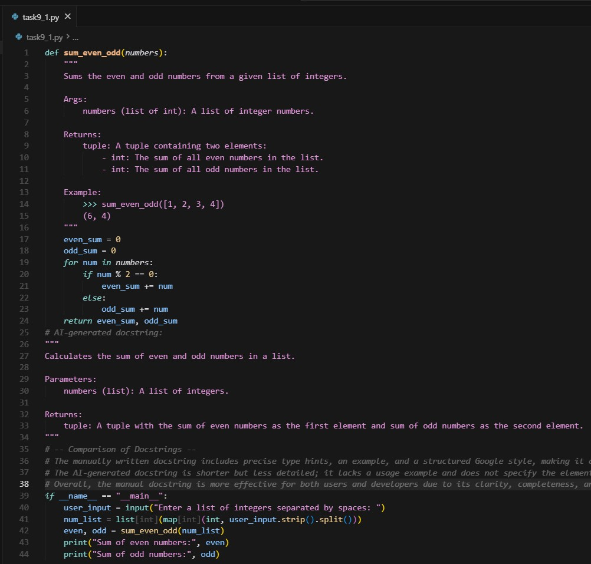  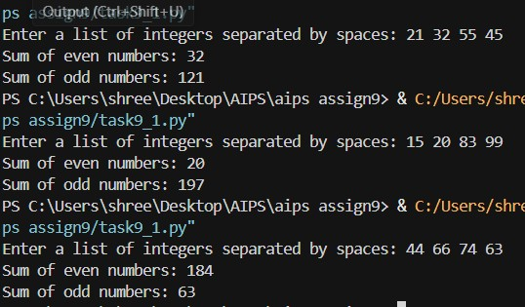  Task Description#2 Automatic Inline Comments  - Write python program for sru_student class with attributes like name, roll no., hostel_status and fee_update method and display_details method.  - Write comments manually for each line/code block  - Ask an AI tool to add inline comments explaining each line/step.  - Compare the AI-generated comments with your manually written one.  Expected Output#2: Students critically analyze AI-generated code comments.  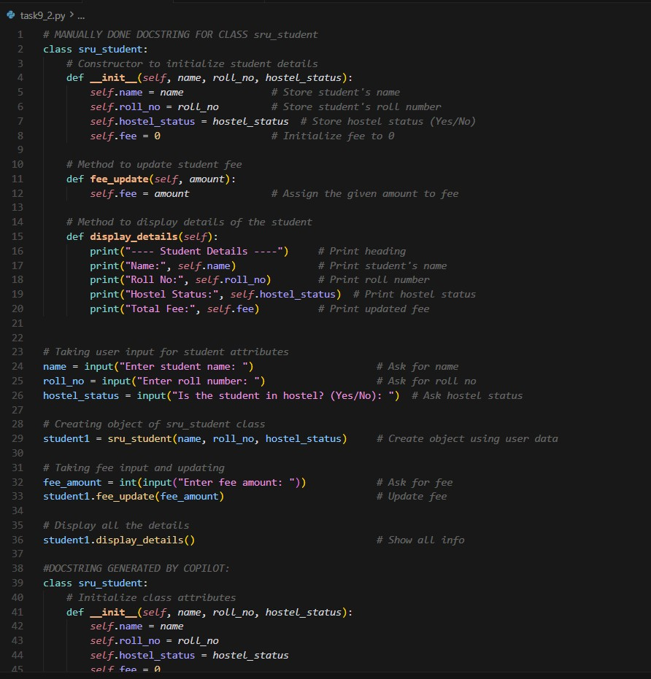  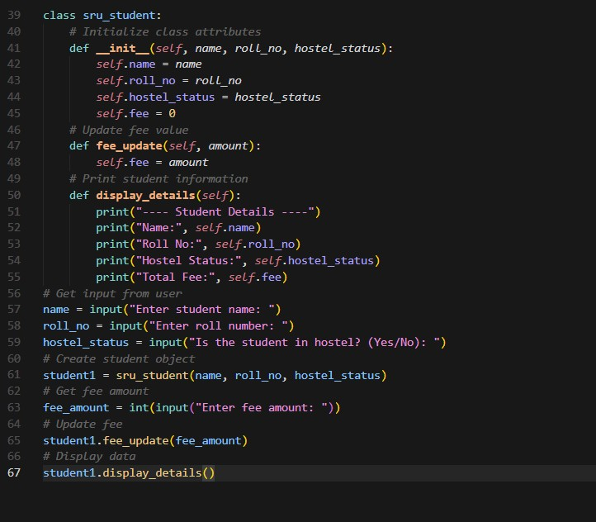  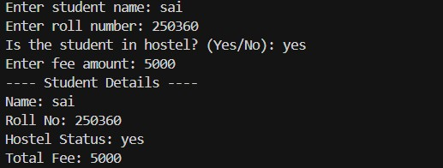  The manually written inline comments provide detailed, step-by-step explanations.They clearly describe what each line does and why it is needed.This helps beginners understand object creation, methods, and program flow.Such comments make the logic easy to follow and improve comprehension.  AI-generated comments, however, are brief and surface-level.They restate actions without explaining the purpose behind them.While concise and neat, they lack depth for educational use.  Overall, manual comments are more instructional, while AI comments work best as quick references.  Task Description#3  - Write a Python script with 3–4 functions (e.g., calculator: add, subtract, multiply, divide).  - Incorporate manual docstring in code with NumPy Style  - Use AI assistance to generate a module-level docstring + individual function docstrings.  - Compare the AI-generated docstring with your manually written one.  Expected Output#3: Students learn structured documentation for multi-function scripts  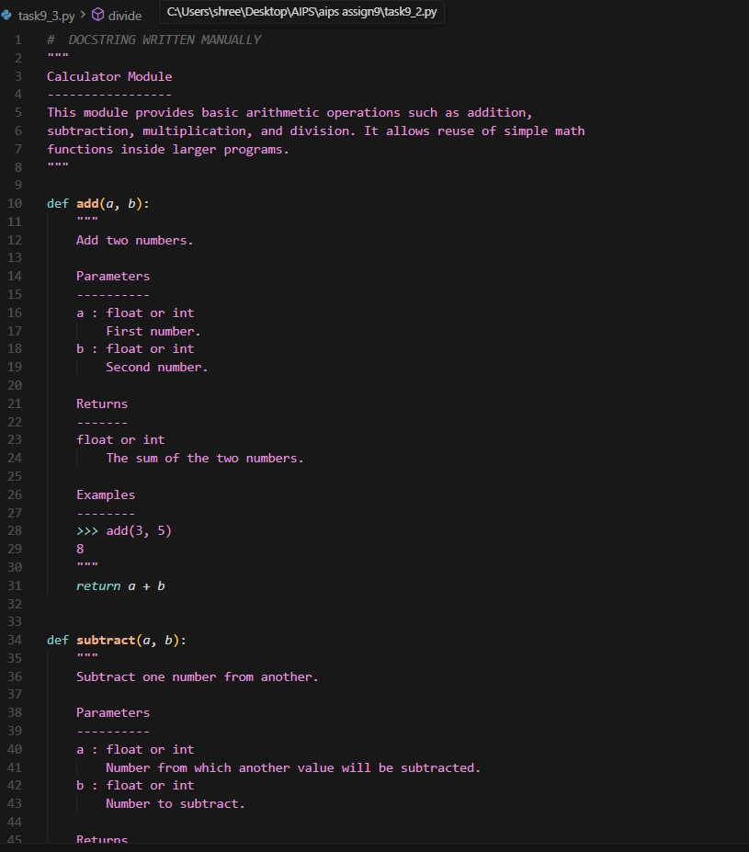  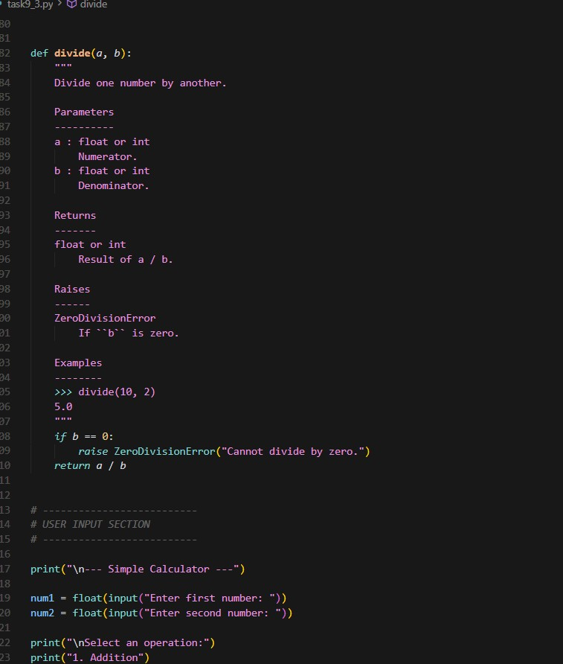  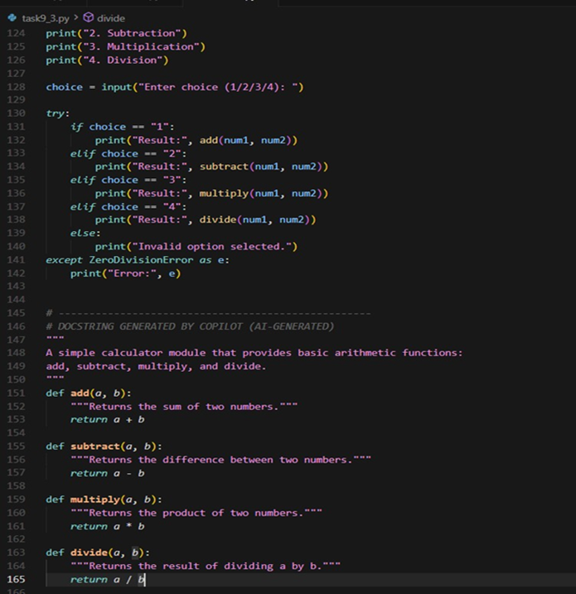  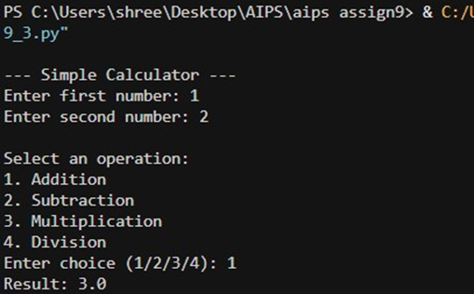  The manually written NumPy-style docstrings are well-structured and professional.They include clear sections like Parameters, Returns, Raises, and Examples.This format helps users understand function usage, expected inputs, outputs, and errors.Such detailed documentation matches industry and research standards.  In contrast, the AI-generated docstrings are brief and shallow.They give only a one-line function description without types or examples.While fast and convenient, they lack clarity and completeness.Thus, they suit prototypes but not production-level or educational documentation. |  |  |  |  |  | Week4 - Wednesday

